A5 – BME280 & LH1750 Sensor
Preparation:
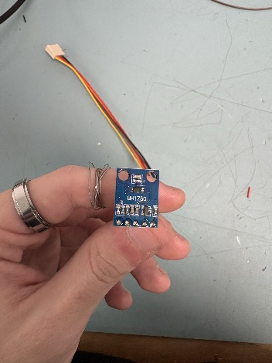
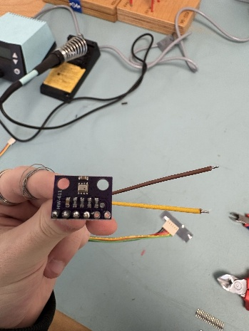
We have a BH1750 light sensor, which will be used to measure the light level, and we also have a BME280 barometric sensor, which will be used to measure the atmospheric pressure.

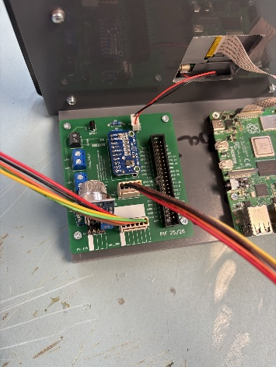
Installing:
We install the BH1750 using the socket strip into the connector marked as light_sensor and for the BME280, we install the socket strip into the connector marked as BME_280.

